Dear Family and Friends
On Saturday, April 30th, 2017, I'll be participating in the biggest fundraiser of the year for the Neighborhood Junior Tennis Program. This year we will be participating in the "Meals on Wheels" Walk/Run/Bike event. This is the 21st annual fundraiser event for the Neighborhood Junior Tennis Program. The NJTP is a non-profit organization, which has taught tennis to thousands of children and adults over the past 24 years. The program has benefited the community by offering low cost tennis instruction in the Northeast San Fernando Valley. To keep their costs low, the NJTP participates in this one BIG fundraiser each year.
I would personally like to ask you if you can donate any amount to the NJTP.
These funds will be used to go toward program costs such as Tennis Balls, T-Shirts, Court Rentals, Website, Insurance, Answering Service, Coaches Fees, Quarterly Newsletters, Tournament entries for students, Scholarships, and Lottery Private Lessons.
- GOLD PLEDGE ($1OO+) You will receive a "Keepsake Memento" and "Smash Talk" Newsletter throughout the year.
• SILVER PLEDGE ($50-$99) You will receive a "Memento of Appreciation” and "Smash Talk" Newsletter throughout the year.
• BRONZE PLEDGE ($10-$49) You will have your name in the Bike-A-Thon issue of "Smash Talk' Newsletter.
Any amount donated
would be greatly appreciated!
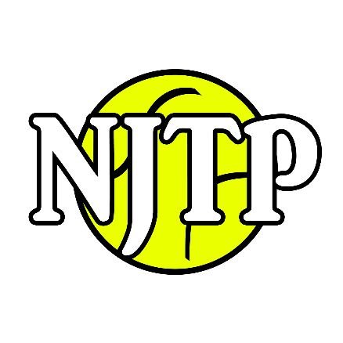
Donors Name: |  |  | Amount Enclosed:
Mailing Address: |  | State: |  | Zip:
City: | Today’s Date:
Name Of Person Who You Are Sponsoring:

Mailing Address: 13083 Hubbard #3, Sylmar CA. 91342
Checks Made Out To: Neighborhood Jr Tennis Program

Tax Deductible: 501(c)3 - 95-4440785
Online Donations: www.njtptennis.net
Thank you
for your contribution!

